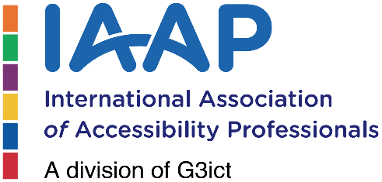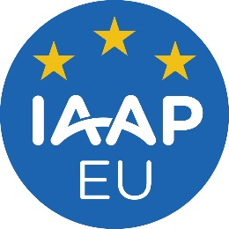
IAAP EU Hybrid Event | Paris | 10-11 April

Event Description

The IAAP EU Accessibility Event focuses on EU-specific content and includes subject matter presentations, policy discussions, expert panels, and discussions.

The two-day hybrid event will be hosted by our co-event partner Atos, at their headquarters in Paris.

10th April, Wednesday 13:00 –18:30

Day one will kick off with a half-day workshop for IAAP members starting at 9 -12. The workshop will be followed by lunch and then a half day of sessions which are open to all. There will be a social activity after day one.

11th April, Thursday 9:00 – 17:00

Day two will be a full day of discussions, panels, personal stories, and networking, with a break for lunch at midday.

Expected Market Impact

- On-site: 100-150 participants, including EU Monitoring agencies.
- Expected virtual registration: 800 - 1200 participants world wide (last event had attendees from over 60 countries).
- Archive event recording will be available on the IAAP YouTube channel for post production promotion and viewing.

Sponsorship and Partnering Opportunities

Gold Sponsorship - USD 8,000 (2 available)

- Delegate from company can attend and introduce 2 sessions
- The company logo will be featured on the webinar post-production YouTube posting.
- The company logo is included on promotional email blasts (estimated 40,000 reach).
- Three newsletter promotions (estimated 30,000 reach).
- The company logo featured during the event and on the event website page.
- The company will be featured on social media promotions on LinkedIn, Facebook, Twitter, and Google Ads.
- IAAP EU, UK, and DACH Chapter promotion of social media outreach.

Silver Sponsorship - USD 5,000 (3 available)
- Delegate from company can attend and introduce 1 session
- The company logo is included on promotional email blasts (estimated 40,000 reach).
- Three newsletter promotions (estimated 30,000 reach).
- The company logo featured during the event and on the event website page.
- The company will be featured on social media promotions on LinkedIn, Facebook, Twitter, and Google Ads.
- IAAP EU, UK, and DACH Chapter promotion of social media outreach.

Lunch Sponsorship (2 available) USD 1,000

- Company logo on event signage during lunch break

Coffee & refreshment breaks (2 available) USD 1,000

- Company logo on event signage during breaks

Evening Social – USD 1,000

- Company logo on event signage during the social event.

For sponsorship offerings, please get in touch with Pat Tessler, G3ict Business Development Officer, at:

(E) pat.tessler@g3ict.org
(P) +1 301 602 0257

